**SP/RM[1,1] – Using Software Cortland Watson**

**Type in your score here 🡪 __30__ out of 30 points possible**

1. (5 points) Ponder/Reflect Exercise – Reflect on what you have learned from this portion of the class. Examples of what you can do are: a brief outline of material covered, insights you gained from class or personal study, or items you feel that you need to follow up or work on. (3-5 sentences)
   1. This week I have lerned a little bit more about Split Plots. I have come to appreciate, the complexity of the design, but at the same time realize how truly simple it is. We are trying to take many factors into consideration, control for nuisance variables, but still allow for clarity in analyzing the data. Although it was difficult at first to understand, it is becoming more clear.
2. Consider the experiment described in Example 7.11 on page 261, with data given on the bottom of page 281.
   1. Using the file auxin.csv on the homework page, run the analysis to check your work from the decomposition homework. Discuss the results of the experiment, including the significance or non-significance of each hypothesis test of interest (i.e., discuss the test for each factor). For the auxin data, answer the following questions:
      1. (5 points) Check the assumption of residuals being normally distributed using **software**.
         1. 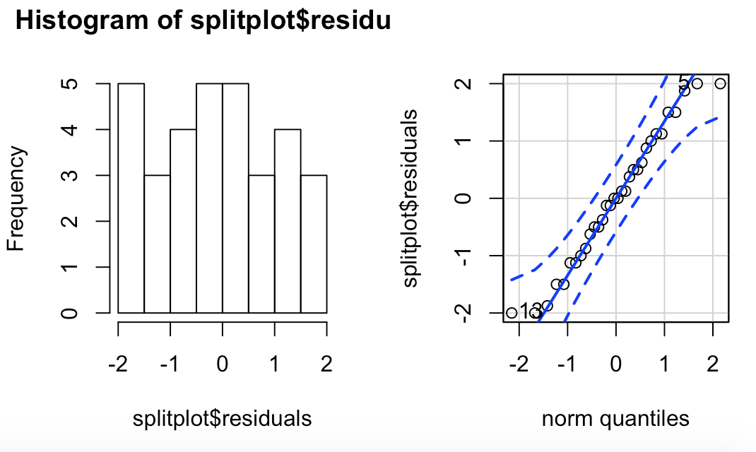
      2. (4 points) Get an ANOVA table using **software**
         1. 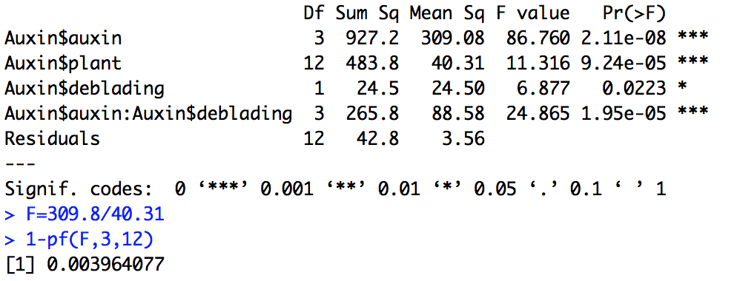
      3. (8 points) For the effect of interest: i) state the null and alternative hypotheses, ii) give the test statistic, iii) give the degrees of freedom, iv) state the p-value, v) determine whether you should reject or not reject the null hypothesis, and vi) write a sentence which gives an appropriate conclusion.
         1. Auxin
            1. Null = population means are the same: alternative = at least one is different
            2. F = 7.727
            3. DF num =3 den = 12
            4. P-value = 0.0039
            5. Reject the null
            6. At least one of the population means is different
         2. Deblading
            1. Null = population means are the same: alternative = at least one is different
            2. F = 6.877
            3. DF num = 3 den = 12
            4. P-value = 0.022
            5. Reject the null
            6. At least one of the means is different
         3. Interaction
            1. Null = There is no interaction between Deblading and Auxin : Alternative = There is an interaction
            2. F = 24.865
            3. DF num = 3 den = 12
            4. P-value = 1.95e-05
            5. Reject the null
            6. There is an interaction between Deblading and Auxin
      4. (1 point) What is the response variable?
         1. Days
      5. (1 point) What are the experimental factors and what are the levels for each?
         1. Auxin; Control, Lanolin, Low and High
      6. (1 point) What blocking used in this study? If so, what are the blocks?
         1. The block is the plant.
      7. What is the statistical model for the observed values, defining all symbols used? (2 points)

* + 1. What are the null and alternative hypotheses using the model in problem vii? (3 points)
       1. Auxin = Null = population means are the same: alternative = at least one is different
       2. Deblading = Null = population means are the same: alternative = at least one is different
       3. Interaction = Null = There is no interaction: Alternative = There is an interaction
       4. All of the null hypothesis are rejected in our analysis. It appears that Auxin and Deblading effect the data to where they each individually change the population means. Also, the Interaction null is rejected pointing that there is an interaction between the two Variables.
          1. 